UNM Taos Syllabus Spring 2022
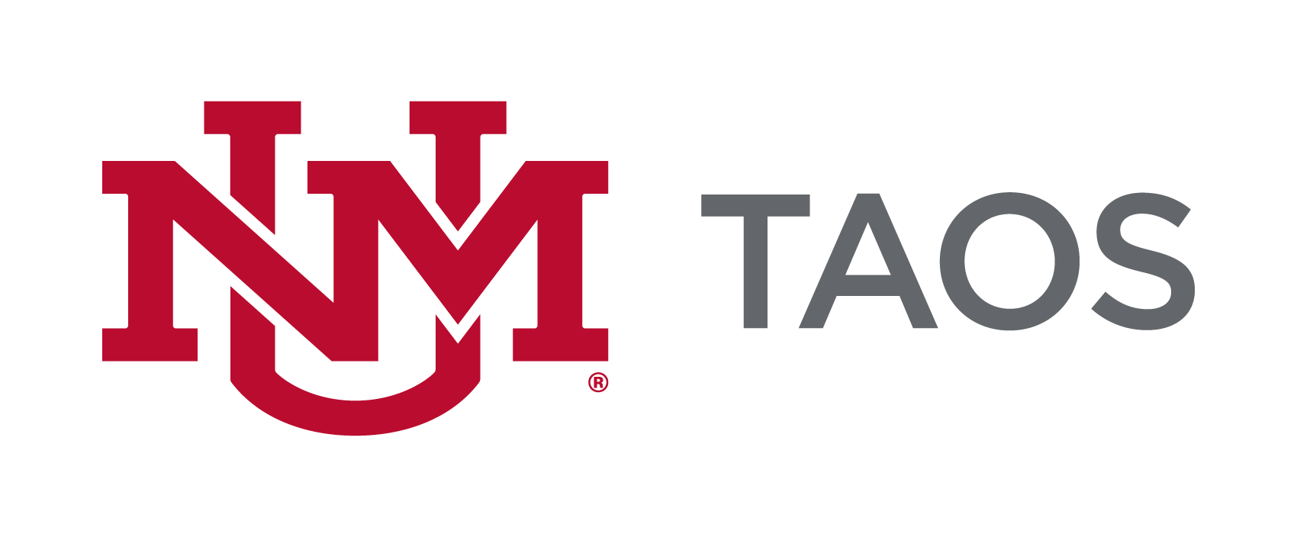
The course syllabus serves as a description and plan for a course and is considered the contract between the faculty and the students in the course. The sample syllabus presented here provides guidance for the minimum requirements as approved by UNM Academic Affairs and UNM Faculty Senate Curriculum Committee. Please include all listed components, inclusive of the UNM-Taos logo, in your preferred template/format. You can include more information but not less than the minimum requirements.

Information written in italics is to be completed by the instructor. All other wording must be included in your syllabus.

UNM-TAOS LAND ACKNOWLEDGEMENT
The University of New Mexico-Taos sits on the traditional homelands of the Red Willow People of Taos Pueblo. The original peoples of current-day New Mexico Pueblo, Navajo, and Apache since time immemorial, have deep connections to the land and have made significant contributions to the broader community statewide. We honor the land itself and those who remain stewards of this land throughout the generations and also acknowledge our committed relationship to Indigenous peoples. We gratefully recognize our history and work to maintain healthy, fruitful relationships with our neighbors for generations to come.

SAMPLE SYLLABUS

Course Title:
Course Number:
(Please use approved Common Course Number if applicable. Please use the following link to find your CCN for your course: http://advisement.unm.edu/resources/common-course-numbering/

Course Credit Hours:

Instructor: UNM Email*:
Office Location: Zoom Office Phone (if applicable):
Office Hours (set by instructor.):

*FERPA requires that all communications between students and faculty are conducted through UNM e-mail addresses only. UNM Taos official communications will only be sent to student and faculty UNM e-mail addresses.

Class Meeting Day(s): Class Time:
Class Location / Room: Term / Semester:
Enter number of hours per week or TBD as appropriate if information is not known

Course Description:
At a minimum enter the description listed in the UNM course catalog. Alternatively, describe the course content, purpose, contributions, etc. and what the learner may expect if enrolled in the course.

If your course is part of the General Education Curriculum (https://gened.unm.edu/), you must note that in your syllabus under the description and include the Essentials Skills (http://assessment.unm.edu/assessment-types/gened-assessment/essential-skills.html)
that your class is assessing. Here is sample language for how a general education course should be entered on your syllabus:
This course meets the New Mexico Lower Division General Education Common Core Curriculum Area IV: Social/Behavioral Sciences. This course teaches three essential skills: Communication, Personal & Social Responsibility, and Critical Thinking, and assesses student mastery of those skills through weekly and periodic assignments (journal entries and discussions, unit exams, and papers).

Please review the courses that comprise the General Education Curriculum at https://gened.unm.edu and review the required essentials skills to be addressed by Area at http://assessment.unm.edu/assessment-types/gened-assessment/essential-skills.html

Course Goals/Objectives:
Course goals are broad, general statement that are directly related/ linked/aligned to programmatic, departmental, or accreditation goals. Describe a practical purpose for the course, often are or relate to core competences. These are general learning outcomes and are not typically assessed. See Appendix 1.

Student Learning Outcomes:
List achievable, measurable skills, knowledge and attitudes that students should be able to do/know upon course completion. Written for learner using action verbs. Provide clear expectations of what needs to be mastered for successful course completion. May be broken down further in lesson or module units.
[See Appendix 1]
For a list of New Mexico Higher Education Department (HED) approved list of Student Learning Outcomes by Department and Course, please go to the following website
https://hed.state.nm.us/uploads/documents/Course_Catalog_V7.pdf
You must include these SLOs at a minimum. For courses not found in this document, you must use a minimum of three SLOs per course that are measurable.

Textbooks/Supplies/Materials/Equipment/ Technology or Technical Requirements:

List the required and/or recommended textbooks (including ISBN #) as well as any other supplies, materials or equipment needed to successfully complete the course. List the technology to which students must have access and the technical requirements of that technology.

Courses requiring specific computer hardware and software should include product specifications needed for student success within the syllabus. These should include minimum computer and software requirements and internet configurations, or a link to a detailed reference document.

Please contact Academic Affairs at (575) 737-6225 for any textbook question. UNM-Taos collaborates with UNM Albuquerque for textbook services.

Course Requirements:
List and describe all assessments, which contribute to course score. May include exams, portfolios, participation, attendance, papers, oral reports, group projects, assignments, etc. Include possible point (percentage) value of each. Please make sure to note policies regarding make-up exams and homework. See Appendix 2.

Student Attendance Policy:
Policies regarding student attendance at class meetings are set by each instructor. However, UNM Taos requires that all faculty have a policy on student attendance and that the policy is clearly articulated on the course syllabus to avoid any confusion on the students’ part for grading purposes. All faculty should be aware of Faculty Handbook Policy C260 of the UNM Faculty Handbook regarding Religious Accommodations.
*Online Instructors must define how attendance will be measured in their courses. Some examples include the following: students’ attendance will be tracked by UNM Learn activity tracking; students must participate in online discussions; or students must log in weekly and submit all coursework on time.

Instructors may drop students from their classes for reasons of excessive absences, per Faculty Handbook Policy D145.

Grading:
Indicate how a final course grade (including credit/no credit) will be assigned, calculated, or otherwise determined. See Appendix 3.
Course Schedule:
List all relevant dates – lecture titles/topics; academic holidays; Spring break, exams, assignment due dates etc. An exact listing in full detail is not necessary – a representative listing is adequate. See Appendix 4.

Disclaimer:
The instructor reserves the right to alter this syllabus to better meet the learning needs of the students. Minor changes will be announced in class, major ones provided in writing.

Accommodation Statement:

In accordance with UNM Policy 2310 and the Americans with Disabilities Act (ADA), academic accommodations may be made for any student who notifies the instructor of the need for accommodation. It is imperative that you take the initiative to bring such needs to the instructor’s attention, as he or she are not legally permitted to inquire. Students who require assistance in emergency evacuations should contact the instructor as to the most appropriate procedures to follow. Contact Accessibility Services, at the Center for Academic Success and Achievement (CASA), to coordinate accommodations and services CASA is located on the Klauer Campus, TSPH West, and can be reached at 575.737.3695.

Title IX Statement:

In an effort to meet obligations under Title IX, UNM faculty, Teaching Assistants, and Graduate Assistants are considered “responsible employees” by the Department of Education (see pg. 15 - http://www2.ed.gov/about/offices/list/ocr/docs/qa-201404-title-ix.pdf). This designation requires that any report of gender discrimination which includes sexual harassment, sexual misconduct and sexual violence made to a faculty member, TA, or GA must be reported to the Title IX Coordinator at the Office of Equal Opportunity (oeo.unm.edu). For more information on the campus policy regarding sexual misconduct, see: https://policy.unm.edu/university-policies/2000/2740.html

Academic Integrity Statement:

The policy of the University of New Mexico addresses the fact that academic honesty is one of the basic steps toward personal and academic development. Each student is expected to maintain the highest standards of honesty and integrity in academic and professional matters.
At UNM, academic dishonesty includes, but is not limited to, dishonesty in quizzes, tests, or assignments; claiming credit for work not done or done by others; hindering the academic work of other students; misrepresenting academic or professional qualifications within or without the University; and nondisclosure or misrepresentation in filling out applications or other University records. University reserves the right to take disciplinary action, up to and including dismissal, against any student who is found guilty of academic dishonesty or otherwise fails to meet the standards. Any student judged to have engaged in academic dishonesty in coursework may receive a reduced or failing grade for the work in question and/or for the course.
The University’s full statement on academic dishonesty and the consequences for failure to comply is available online at http://pathfinder.unm.edu/campus-policies/academic-dishonesty.html.

Netiquette Statement: Standards of courtesy and respect must be always maintained in our online classrooms. Join in the discussion, but remember that this is still a classroom setting and that respect and consideration are crucial for any intellectual discussion. Name-calling and personal attacks are not permitted. Any violation of the standards of appropriate behavior online may result in your being dropped from this course and reported to the Dean of Instruction. The University’s full statement on netiquette is available online at http://online.unm.edu/help/learn/students/intro-to-online-tools/netiquette.html

Dropping the course: Students should not assume that nonattendance results in being dropped from the class. It is the student’s responsibility to initiate drops or complete withdrawals utilizing http://registrar.unm.edu/ or LoboWeb at http://my.unm.edu/.

UNM-Taos Library:
All students are encouraged to utilize library services as an additional resource for this course. Here is the link to the UNM-Taos Library: https://taoslibrary.unm.edu/library.

CASA (Center for Academic Success and Achievement):
All students are encouraged to utilize the CASA tutoring services offered free through UNM-Taos: https://taos.unm.edu/students/casa.html

Student Referral Request Form
UNM-Taos Student Support Request Form (qualtrics.com)

Due Process/Student Grievance Procedure:
If a student has a problem in class that cannot be handled by talking directly to the instructor, which would be the first step, the appropriate person to contact is the Program Coordinator or Department Chair if there is not a Program Coordinator for that course, in the program you are enrolled in. You can find Program Coordinators and Department Chairs online under the Department page for Academic Affairs at: https://taos.unm.edu/academics/office-of-academic-affairs.html . The Dean of Instruction/Chief Academic Officer is the last step if all matters remain unresolved.

Respect the UNM Community by Preserving Health

You have the ability to prevent the spread of COVID-19 and to preserve the health of fellow students, your instructor, staff and the community by following UNM health protocols. These are consistent with the NM Department of Health. Up to date information related to UNM’s COVID response can be found at the following link: https://www.unm.edu/coronavirus/ .

UNM Administrative Mandate On Required COVID-19 Vaccination

Purpose: To protect and preserve the health, safety and welfare of the UNM community, the University of New Mexico will require that all faculty, staff and students accessing University facilities and programs be fully vaccinated for COVID-19 as soon as possible, but no later than September 30, 2021. This mandate requires all UNM faculty, staff and students who access campus facilities, housing, programs, services and activities in person to be fully vaccinated for COVID-19, subject to limited exemptions.

UNM-Taos Requirement on Masking in Indoor Spaces
All students, staff, and instructors are required to wear face masks in indoor classes, labs, studios and meetings on UNM-Taos’ campus. Vaccinated and unvaccinated instructors teaching in classrooms must wear a mask at all times when indoors. Students who do not wear a mask indoors at UNM-Taos should first be offered a mask by the instructor and then can expect to be asked to leave the classroom and to be dropped from a class if failure to wear a mask occurs more than once in that class. With the exception of the limited cases described above, students and employees who do not wear a mask in classrooms and other indoor public spaces on UNM campuses are subject to disciplinary actions.
Acceptable masks and mask wearing in class: A two-layer mask that covers the nose and mouth and that is cleaned regularly is acceptable, as are disposable medical masks, KN95, KF94, FFP1 and FFP2 masks. A face shield is not sufficient protection. It is vital that you wear your mask correctly, covering your nose and mouth. Removing your mask for an extended period to eat or drink in class violates the university mask requirement and endangers others.
Consequences of not wearing a mask properly: If you don’t wear a mask, or if you do not wear a mask properly by covering your nose and mouth, you will be asked to leave class. If you fail to wear a mask properly on more than one occasion, you can expect to be dropped from the class. If you insist on remaining in the classroom while not wearing a mask, class will be dismissed for the day to protect others and you will be dropped from the class immediately.
The instructor will try to have a few disposable masks available on a first-come, first-served basis.
Communication on change in modality: The President and Provost of UNM may direct that classes move to remote delivery at any time to preserve the health and safety of the students, instructor and community. Please check your UNM e-mail regularly for updates about our class and please check https://bringbackthepack.unm.edu regularly for general UNM updates about COVID-19 and the health of our community.

Course Calendar

Date | Topic | Assignment

