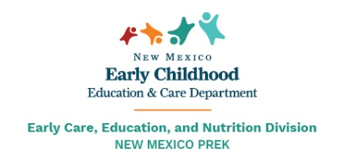

New Mexico Early PreK Application 2022-2023
Please return completed form on or before April 1 to:
UNM Taos Kid’s Campus
1157 County Rd 110
Ranchos de Taos, NM 87557

The lottery drawing will be held on April 4, 2022. All applications received after April 1, 2022 will be added to the end of the waiting list established by the lottery drawing. Completion of this form does not prevent or guarantee a student’s enrollment in UNM Taos Kid’s Campus Pre-K program. All students must be 3 years old before September 1, 2022 to be eligible early PreK Program. For more information, please call (575)737-6295 or (575)737-6255.

Program Type: ☐ Early PreK
All information should be the same as Childcare Assistance application if applicable.
Early Pre K Student Information
Legal First Name: _________________Legal Middle Name: _____________ Legal Last Name: _____________________ Suffix: ________
Date of Birth: _____________________ Verified by Birth Certificate: ☐ Gender: ☐ Male ☐ Female ☐ Other

Email Address: _____________________________________
Phone: __________________________

I verify that the information provided in this application is accurate as of today’s date: _________

Program Printed Name: ___________________________ Program Signature: ___________________________
Parent/Guardian Printed: __________________________Parent/Guardian Signature: _________________________

