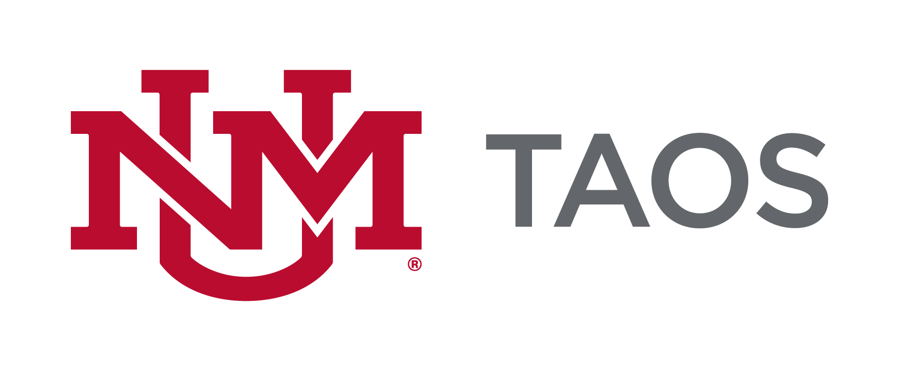
The course syllabus serves as a description and plan for a course and is considered the contract between the faculty and the students in the course. The sample syllabus presented here provides guidance for the minimum requirements as approved by UNM Taos Department of Instruction and UNM Faculty Senate Curriculum Committee. Please include all listed components in your preferred template/format. You can include more information but not less than the minimum requirements.

Information written in italics is to be completed by the instructor. All other wording must be included in your syllabus.

SAMPLE SYLLABUS

Course Title:
Course Number:
Course Credits:

Instructor: UNM Email*:
Office Location (if applicable): Office Phone (if applicable):
Office Hours (or for adjunct faculty, procedure for meeting with the faculty outside of class time, such as before or after class, in the Department of Instruction conference room, by appointment, etc.):

*FERPA requires that all communications between students and faculty are conducted through UNM e-mail addresses only. UNM Taos official communications will only be sent to student and faculty UNM e-mail addresses.

Class Meeting Day(s): Class Time:
Class Location / Room: Term / Semester:
Enter number of hours per week or TBD as appropriate if information is not known

Course Description:
At a minimum enter the description listed in the UNM course catalog. Alternatively, describe the course content, purpose, contributions, etc and what the learner may expect if enrolled in the course.

Course Goals/Objectives:
Course goals are broad, general statement that are directly related/ linked/ aligned to programmatic, departmental, or accreditation goals. Describe a practical purpose for the course, often are or relate to core competences. These are general learning outcomes and are not typically assessed. See Appendix 1.

Student Learning Outcomes:
List achievable, measurable skills, knowledge and attitudes that students should be able to do/know upon course completion. Written for learner using action verbs. Provide clear expectations of what needs to be mastered for successful course completion. May be broken down further in lesson or module units. See Appendix 1.
For General Education Core courses (UNM Core Curriculum), please go to the following website: http://taos.unm.edu/home/department-of-instruction/assessment/general-education-core-course-assessment/
for required Student Learning Outcomes per UNM. You must include these SLOs at a minimum. For non-Core courses, you must use a minimum of three SLOs per course that are measurable.
***For spring 2019, please adopt the required Higher Education Department’s (HED) SLOs from their Common Course Numbering System at the following website: http://www.hed.state.nm.us/programs/common-course-numbering.aspx
Scroll to the bottom to your subject code and find your class. These will be the new required SLOs by fall 2019.

Textbooks/Supplies/Materials/Equipment/ Technology or Technical Requirements:

List the required and/or recommended textbooks (including ISBN #) as well as any other supplies, materials or equipment needed to successfully complete the course. List the technology to which students must have access and the technical requirements of that technology.

Courses requiring specific computer hardware and software should include product specifications needed for student success within the syllabus. These should include minimum computer and software requirements and internet configurations, or a link to a detailed reference document.

Please contact Carol in the Department of Instruction (575) 737-6225 for any textbook question. UNM Taos collaborates with MBS direct for textbook services.

Course Requirements:
List and describe all assessments, which contribute to course score. May include exams, portfolios, participation, attendance, papers, oral reports, group projects, assignments, etc. Include possible point (percentage) value of each. See Appendix 2.

Student Attendance Policy:
Policies regarding student attendance at class meetings are set by each instructor. However, UNM Taos requires that all faculty have a policy on student attendance and that the policy is clearly articulated on the course syllabus to avoid any confusion on the students’ part for grading purposes. All faculty should be aware of Faculty Handbook Policy C260 of the UNM Faculty Handbook regarding Religious Accommodations.

Instructors may drop students from their classes for reasons of excessive absences, per Faculty Handbook Policy D145.

Grading:
Indicate how a final course grade (including credit/no credit) will be assigned, calculated, or otherwise determined. See Appendix 3.

Course Schedule:
List all relevant dates – lecture titles/topics; academic holidays; Spring break, exams, assignment due dates etc. An exact listing in full detail is not necessary – a representative listing is adequate. See Appendix 4.

Disclaimer:
The instructor reserves the right to alter this syllabus to better meet the learning needs of the students. Minor changes will be announced in class, major ones provided in writing.

Accommodation Statement:

In accordance with UNM Policy 2310 and the Americans with Disabilities Act (ADA), academic accommodations may be made for any student who notifies the instructor of the need for accommodation. It is imperative that you take the initiative to bring such needs to the instructor’s attention, as he or she are not legally permitted to inquire. Students who require assistance in emergency evacuations should contact the instructor as to the most appropriate procedures to follow. Contact Accessibility Services, at the Center for Academic Success and Achievement (CASA), to coordinate accommodations and services CASA is located on the Klauer Campus, TSPH West, and can be reached at 575.737.3695.

Title IX Statement:

In an effort to meet obligations under Title IX, UNM faculty, Teaching Assistants, and Graduate Assistants are considered “responsible employees” by the Department of Education (see pg 15 - http://www2.ed.gov/about/offices/list/ocr/docs/qa-201404-title-ix.pdf). This designation requires that any report of gender discrimination which includes sexual harassment, sexual misconduct and sexual violence made to a faculty member, TA, or GA must be reported to the Title IX Coordinator at the Office of Equal Opportunity (oeo.unm.edu). For more information on the campus policy regarding sexual misconduct, see: https://policy.unm.edu/university-policies/2000/2740.html

Academic Integrity Statement:

The policy of the University of New Mexico addresses the fact that academic honesty is one of the basic steps toward personal and academic development. Each student is expected to maintain the highest standards of honesty and integrity in academic and professional matters.
At UNM, academic dishonesty includes, but is not limited to, dishonesty in quizzes, tests, or assignments; claiming credit for work not done or done by others; hindering the academic work of other students; misrepresenting academic or professional qualifications within or without the University; and nondisclosure or misrepresentation in filling out applications or other University records. University reserves the right to take disciplinary action, up to and including dismissal, against any student who is found guilty of academic dishonesty or otherwise fails to meet the standards. Any student judged to have engaged in academic dishonesty in coursework may receive a reduced or failing grade for the work in question and/or for the course.
The University’s full statement on academic dishonesty and the consequences for failure to comply is available online at http://pathfinder.unm.edu/campus-policies/academic-dishonesty.html.

Dropping the course: Students should not assume that nonattendance results in being dropped from the class. It is the student’s responsibility to initiate drops or complete withdrawals utilizing http://registrar.unm.edu/ or LoboWeb at http://my.unm.edu/ .

UNM Taos Library:
All students are encouraged to utilize library services as an additional resource for this course. Here is the link to the UNM-Taos Library : http://taos.unm.edu/library/

CASA (Center for Academic Success and Achievement):
All students are encouraged to utilize the CASA tutoring services offered free through UNM-Taos: http://taos.unm.edu/home/casa/

Due Process/Student Grievance Procedure:
If a student has a problem in class that cannot be handled by talking directly to the instructor, which would be the first step, the appropriate person to contact is the Department Chair in the program you are enrolled in. A list of Department Chairs can be found in the UNM Taos course schedule or online at http://taos.unm.edu/home/academics-2/. If the issue/concern has not been resolved after this, please contact the appropriate Area Coordinator (at the above link). The Dean of Instruction is the last step if all matters remain unresolved.

Course Calendar

Date | Topic | Assignment

