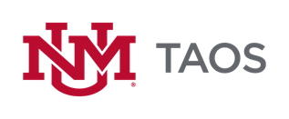
Student Government Association
Business Meeting Notes For:
February 15, 2024
Attendees: Juan Carlos, Alyson, Darian, Alan, Kyle,
Call to Order
- Meeting was called to order at 4:45
Open Forum
- N/A
Treasurer Report
- Alan will report back on treasurer budget.
Committee updates
- Student Lounge Committee proposal,
- $500 dollar budget (maintenance/improvements).
- Bulletin board/community board for the student lounge
- Announcement monitors installed.
- QR code to contact SGA (host event, learn more)
- Alan suggests adopting another bulletin board.
- Input on security - Jonathan is going to have access to the camera in the student lounge hopefully soon and Jonathan is going to have his office closer.
- Crating a monthly maintenance checklist and a semester checklist for student lounge.
- Darian and Alyson suggest adding Minecraft to SL console.
- By law committee – Alan, Darian, Alyson,
Old Business
- Alan contacted the Café lady about catering future events.
- She is possibly able in the future with at least a week’s notice.
New Business
- Kyle presents on how to use Teams.
- Alyson proposes trying to make transitioning between and UNM toas and other collages and high schools.
- Group discusses bylaws and transition.
- By Law committee – everyone
Announcement of next meeting – February 22nd
Meeting adjourned – 5:57

