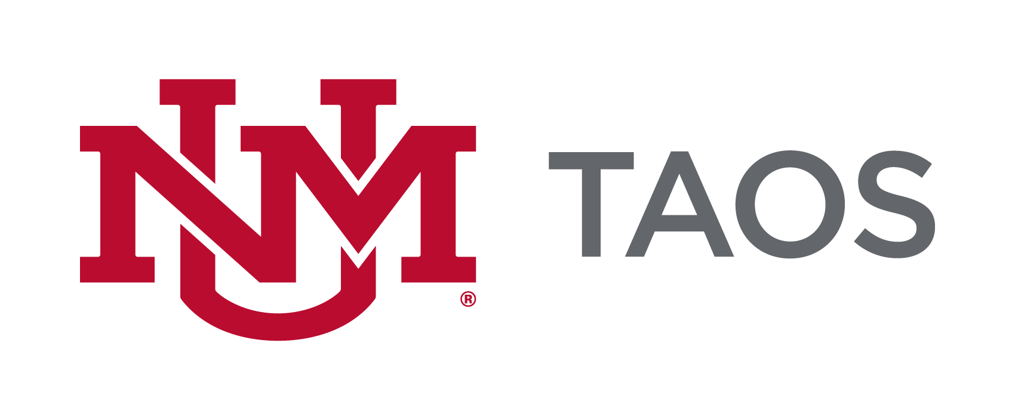
The course syllabus serves as a description and plan for a course and is considered the contract between the faculty and the students in the course. The sample syllabus presented here provides guidance for the minimum requirements as approved by UNM Academic Affairs and UNM Faculty Senate Curriculum Committee. Please include all listed components, inclusive of the UNM-Taos logo, in your preferred template/format. You can include more information but not less than the minimum requirements.

Information written in italics is to be completed by the instructor. All other wording must be included in your syllabus.

UNM-TAOS LAND ACKNOWLEDGEMENT

The University of New Mexico-Taos sits on the traditional homelands of the Red Willow People of Taos Pueblo. The original peoples of current-day New Mexico Pueblo, Navajo, and Apache since time immemorial, have deep connections to the land and have made significant contributions to the broader community statewide. We honor the land itself and those who remain stewards of this land throughout the generations and also acknowledge our committed relationship to Indigenous peoples. We gratefully recognize our history and work to maintain healthy, fruitful relationships with our neighbors for generations to come.

SYLLABUS

Course Title:

Course Number:
(Please use the approved Common Course Number if applicable. Please use the following link to find your CCN for your course: http://advisement.unm.edu/resources/common-course-numbering/

Class Meeting Day(s): Class Time:
Class Location / Room: Term/Semester:
Course Credit Hours:

Instructor: UNM Email*:
Office Location: Office Phone (if applicable):
Office Hours (set by instructor.):
*FERPA requires that all communications between students and faculty are conducted through UNM e-mail addresses only. UNM Taos official communications will only be sent to student and faculty UNM e-mail addresses.

Course Description:
At a minimum enter the description listed in the UNM course catalog. Alternatively, describe the course content, purpose, contributions, etc. and what the learner may expect if enrolled in the course.

If your course is part of the General Education Curriculum (https://gened.unm.edu/), you must note that in your syllabus under the description and include the Essentials Skills
(https://gened.unm.edu/essential-skills.html).
Example: This course meets the New Mexico Lower Division General Education Common Core Curriculum Area IV: Social/Behavioral Sciences. This course teaches three essential skills: Communication, Personal & Social Responsibility, and Critical Thinking, and assesses student mastery of those skills through weekly and periodic assignments (journal entries and discussions, unit exams, and papers).

Course Goals/Objectives:
Course goals are broad, general statement that are directly related/ linked/aligned to programmatic, departmental, or accreditation goals. Describe a practical purpose for the course, often are or relate to core competences. These are general learning outcomes and are not typically assessed. See Appendix 1.

Student Learning Outcomes:
List achievable, measurable skills, knowledge and attitudes that students should be able to do/know upon course completion, use action verbs. Provide clear expectations of what needs to be mastered for successful course completion. May be broken down further in lesson or module units.
[See Appendix 1]
For a list of New Mexico Higher Education Department (HED) approved list of Student Learning Outcomes by Department and Course, please go to the following website: https://hed.state.nm.us/uploads/documents/Course_Catalog_V7.pdf
You must include these SLOs at a minimum. For courses not found in this document, you must use a minimum of three SLOs per course that are measurable.

Textbooks/Supplies/Materials/Equipment/ Technology or Technical Requirements:

List the required and/or recommended textbooks (including ISBN #) as well as any other supplies, materials or equipment needed to successfully complete the course. List the technology to which students must have access and the technical requirements of that technology.

Courses requiring specific computer hardware and software should include product specifications needed for student success within the syllabus. These should include minimum computer and software requirements and internet configurations, or a link to a detailed reference document.

To order books go to the website https://bookstore.unm.edu/courselistbuilder.aspx
If you are having trouble, call the textbook department for assistance at 505-277-7480 or email with questions at text@unm.edu.

Course Requirements:
List and describe all assessments which contribute to course score. May include exams, portfolios, participation, attendance, papers, oral reports, group projects, assignments, etc. Include possible point (percentage) value of each. Please make sure to note policies regarding make-up exams and homework. See Appendix 2.

Credit Hour Statement:
Each credit hour corresponds to a minimum of 3 hours of student engagement per week for each credit hour. This time may be spent on learning activities as outlined in the course syllabus.
Accelerated (8 or 12-week) minimum hours increase proportionately. Please customize to reflect learning activities in your course.

Student Attendance Policy:
Policies regarding student attendance at class meetings are set by each instructor. However, UNM - Taos requires that all faculty have a policy on student attendance and that the policy is clearly articulated on the course syllabus to avoid any confusion on the students’ part for grading purposes. All faculty should be aware of Faculty Handbook Policy C260 of the UNM Faculty Handbook regarding Religious Accommodations.
*Online Instructors must define how attendance will be measured in their courses. Some examples include the following: students’ attendance will be tracked by UNM Canvas activity tracking; students must participate in online discussions; or students must log in weekly and submit all coursework on time.

Instructors may drop students from their classes for reasons of excessive absences, per Faculty Handbook Policy D145.

Grading:
Indicate how a final course grade (including credit/no credit) will be assigned, calculated, or otherwise determined. See Appendix 3.
Course Schedule:
List all relevant dates – lecture titles/topics; academic holidays; Spring break, exams, assignment due dates etc. An exact listing in full detail is not necessary – a representative listing is adequate. See Appendix 4.

Disclaimer:
The instructor reserves the right to alter this syllabus to better meet the learning needs of the students. Minor changes will be announced in class, major ones provided in writing.

Accommodation/Accessibility Statement:
In accordance with UNM Policy 2310 and the Americans with Disabilities Act (ADA), academic accommodations may be made for any student who notifies the instructor of the need for accommodation. It is imperative that you take the initiative to bring such needs to the instructor’s attention, as he or she may not legally be permitted to inquire. Students who require assistance in emergency evacuations should contact the instructor as to the most appropriate procedures to follow. Contact Accessibility Services, at the Center for Academic Success and Achievement (CASA), to coordinate accommodations and services CASA is located in the Pathways building on the Klauer Campus and can be reached at 575.737.6257.

Title IX Statement:
To meet obligations under Title IX, UNM faculty, Teaching Assistants, and Graduate Assistants are considered “responsible employees.” This designation requires that any report of gender discrimination, which includes sexual harassment, sexual misconduct and sexual violence, made to a faculty member, TA, or GA must be reported to the Title IX Coordinator at the Office Compliance, Ethics and Equal Opportunity (ceeo.unm.edu). For more information on the campus policy regarding sexual misconduct and reporting, see: https://policy.unm.edu/university-policies/2000/2740.html.

Respectful and Responsible Learning:
We all have shared responsibility for ensuring that learning occurs safely, honestly, and equitably. Submitting material as your own work that has been generated on a website, in a publication, by an artificial intelligence algorithm, by another person, or by breaking the rules of an assignment constitutes academic dishonesty. It is a student code of conduct violation that can lead to a disciplinary procedure. Please ask me for help in finding the resources you need to be successful in this course. I can help you use study resources responsibly and effectively. Off-campus paper writing services, problem-checkers and services, websites, and AIs can produce incorrect or misleading results. Learning the course material depends on completing and submitting your own work. UNM preserves and protects the integrity of the academic community through multiple policies including policies on student grievances (Faculty Handbook D175 and D176), academic dishonesty (FH D100), and respectful campus (FH CO9). These are in the Student Pathfinder (https://pathfinder.unm.edu) and the Faculty Handbook (https://handbook.unm.edu).

Academic Integrity Statement:
All instructors MUST add their policy regarding the use of Generative AI and any related consequences of misuse. * See appendix 4 for examples.

The policy of the University of New Mexico addresses the fact that academic honesty is one of the basic steps toward personal and academic development. Each student is expected to maintain the highest standards of honesty and integrity in academic and professional matters.
At UNM, academic dishonesty includes, but is not limited to, dishonesty in quizzes, tests, or assignments; claiming credit for work done by others; or the use of unauthorized use of generative AI / ChatGPT, hindering the academic work of other students; misrepresenting academic or professional qualifications within or without the University; and nondisclosure or misrepresentation in filling out applications or other University records. The University reserves the right to take disciplinary action, up to and including dismissal, against any student who is found guilty of academic dishonesty or otherwise fails to meet the standards. Any student judged to have engaged in academic dishonesty in coursework may receive a reduced or failing grade for the work in question and/or for the course.
The University’s full statement on academic dishonesty and the consequences for failure to comply is available online at UNM Pathfinder Academic Dishonesty.

Netiquette Statement:
Standards of courtesy and respect must be always maintained in our online classrooms. Join in the discussion but remember that this is still a classroom setting and that respect and consideration are crucial for any intellectual discussion. Name-calling and personal attacks are not permitted. Any violation of the standards of appropriate behavior online may result in your being dropped from this course and reported to the Dean of Instruction. Netiquette details for discussions can be found at UNM Canvass Netiquette Guidelines.

Dropping the course:
Students should not assume that nonattendance results in being dropped from the class. It is the student’s responsibility to initiate drops or complete withdrawals utilizing UNM Office of the Registrar or LoboWeb

Citizenship and/or Immigration Status:
All students are welcome in this class regardless of citizenship, residency, or immigration status. Your professor will respect your privacy if you choose to disclose your status. As for all students in the class, family emergency-related absences are normally excused with reasonable notice to the professor, as noted in the attendance guidelines above. UNM as an institution has made a core commitment to the success of all our students, including members of our undocumented community. The Administration’s welcome is found on our website: http://undocumented.unm.edu/.

UNM-Taos Library:
All students are encouraged to utilize library services as an additional resource for this course. Please visit: UNM-Taos Library

CASA (Center for Academic Success and Achievement):
All students are encouraged to utilize the CASA tutoring services offered free through UNM-Taos: UNM Taos CASA

Resources if You Need Help:
Student Support: Academic and basic needs support (accessing services such as food, housing, emergency funds, behavioral/medical health, childcare etc.) are available to students by filling out the Student Support Request (SSR) Form. Filling out this form will generate an email to the support service indicated (you may select more than one). A support service staff will reach out to you using the contact information provided. Please click the link UNM Taos Student Support Request

Timelycare Platform:
Medical as well as counseling is now available to students for 24/7 access to virtual care services. If students have questions, they can contact Cami at (575) 737-3697 or by e-mail at chartman8@unm.edu . https://timelycare.unm.edu/

NM Crisis Hotline:

If you or a loved one is experiencing any kind of emotional crisis, mental health or substance use concern, you can find help 24 hours a day, seven days a week, by calling the NM crisis and access line or peer to peer warmline 1-855-NMCRISIS (662-7474)

Due Process/Student Grievance Procedure:
If a student has a problem in class that cannot be handled by talking directly to the instructor, which would be the first step, the appropriate person to contact is the Program Coordinator or Department Chair if there is not a Program Coordinator for that course, in the program you are enrolled in. You can find Program Coordinators and Department Chairs online under the UNM Taos Department page for Academic Affairs. The Dean of Instruction/Chief Academic Officer is the last step if all matters remain unresolved.

UNM-Taos Safety, Masking:
UNM is a mask friendly, but not a mask required, community. If you are experiencing COVID-19 symptoms, please do not come to class. If you do need to stay home, please communicate with me. Let me, an advisor, or another UNM staff member know that you need support so that we can connect you to the right resources. Please be aware that UNM will publish information on websites and email students about any changes to our public health status and community response.
Up to date information related to UNM’s COVID response can be found at the following link: https://www.unm.edu/covid/.

Course Calendar
A weekly instructional plan is required. You may use the table below or create a schedule of weekly activities.

Date | Topic | Assignment

